**Anti-lock Braking System**

# Name:Shubham Gujar

# Unique ID: 2005120



Contents

Name: mayur balsaheb padade 1

Unique ID: 2005451 1

[List of figures 3](#_bookmark0)

[List of Tables 4](#_bookmark1)

[Chapter 1 5](#_bookmark2)

[Introduction 5](#_bookmark3)

[Chapter 2 7](#_bookmark5)

[Modelling 7](#_bookmark6)

[Equations Used 7](#_bookmark7)

[Input Parameter 8](#_bookmark8)

[Chapter 3 9](#_bookmark10)

[Skill Demonstrated 9](#_bookmark11)

[Chapter 4 11](#_bookmark12)

[Results 11](#_bookmark13)

[Chapter 5 12](#_bookmark15)

[Conclusion 12](#_bookmark16)

[References 13](#_bookmark17)

# List of figures

[Figure 1 BOSCH closed loop control strategy 6](#_bookmark4)

Figure 2 block diagram of ABS 7

[Figure 3 model simulation output 11](#_bookmark14)

# List of Tables

[Table 1 Input Parameter 8](#_bookmark9)

## Chapter 1

# Introduction

Deadly accidents occurs on roads frequently now-a-days. Research in vehicle dynamics and control engineering is getting advancement day by day. Different techniques and ways are being discovered. Among such anti-Lock Braking System (ABS) is one. It is an active system which is used to control vehicle dynamics under braking. Vehicles which are not equipped with ABS face locking condition when applied excessive braking. In which a tire gets locked. When tire gets locked then friction coefficient falls below sliding value. Thus the ability of vehicle to sustain side force is reduced to null. Therefore, stopping distance increases and directional vehicle while turning losses its grip. So the vehicle gets out of control and derails which cause fatal accidents.

The target of ABS (Antilock braking system) is to produce the biggest conceivable braking power progressively while keeping the vehicle stable and avoiding excessive wheel slippage. ABS works when the braking force is more than the force of adhesion. The ABS screens the pace of every wheel to identify locking. When it recognizes sudden breaking, it will discharge breaking pressure for a moment and then continue optimum braking pressure to each wheel. By repeating this procedure in brief time frame, it upgrades steering control amid sudden stops. Thus, it will likewise enhance the soundness of halting the vehicle. Accordingly, ABS advantages in two ways: You will stop prior, and you will have the capacity to direct while you stop.

Coefficient of friction between tire and road, the tire slip proportion, and the vertical force on the wheel are the essential procedure parameters influencing the control quality. The estimation of slip ratio between wheel and road surface is highly uncertain.

The reason for this instability for the most part comprises of vertical contact force between tire and the road surface, slip ratio and sometimes rapid variation of the road conditions with its related large variations of friction coefficients. The plant to be controlled incorporates elastically suspended wheel, braking servo system and actuator. Figure 1 shows the typical closed loop strategy of BOSCH ABS.

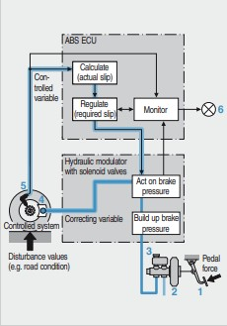

*Figure 1 BOSCH closed loop control strategy*

## Chapter 2

# Modelling

In this project, the ABS follows the block diagram shown below. It is modeled using Simulink subsystems to represent vehicle speed, wheel speed, slip calculation and stopping distance. Antilock braking mechanism enhances the vehicle steadiness and steering ability to stop a vehicle wheel without locking and minimizing stopping distance.

Pedal force

Master cylinder

Wheel speed sensor

Wheel brakes

ABS ECU

*Figure 2 block diagram of ABS*

# Equations Used

*Figure 2 Block diagram of ABS*

The wheel rotates with an initial angular speed that corresponds to the vehicle speed before the brakes are applied. We used separate integrators to compute wheel angular speed and vehicle speed. We use two speeds to calculate slip, which is determined by Equation 1. Note that we introduce vehicle speed expressed as an angular velocity (see below).

$$\omega_v = \frac{V}{R} \mbox{ (equals the wheel angular speed if there is no slip)}$$

**Equation 1**

$$ \omega_v = \frac{V_v}{R_r}$$

$$slip=1-\frac{\omega_w}{\omega_v}$$

$$\omega_v = \mbox{ vehicle speed divided by wheel radius}$$$$ V_v = \mbox{ vehicle linear velocity}$$$$ R_r = \mbox{ wheel radius}$$$$ \omega_w = \mbox{ wheel angular velocity}$$

# Input Parameter

*Table 1 Input Parameter*

|  |  |
| --- | --- |
| Parameters | Values |
| Radius of the wheel (Rr) | 1.25m |
| Mass of the vehicle (m) | 50kg |
| Moment of Inertia (I) | 5 kgm2 |
| Gravitational Constant(g) | 9.81m/s2 |
| Brake force (Kf) | 1 |
| Linear velocity of vehicle (𝑉) | 88m/s2 |
| Desired slip | 0.2 |
| Maximum brake force(PBmax) | 1500Nm |

## Chapter 3

# Skill Demonstrated

### Callback functions

Callbacks are commands that execute in response to a specific modeling action, such as opening a model, starting a simulation or stopping a simulation. They can be used to execute MATLAB codes.

In this project, the Callback function is used to load variables with values when the model is opened. To do so, a MATLAB script named “initialization.m” which consists of all the initial values of variables is define. It is then added o the ‘PreLoadFcn’ pane under Modelling – Model explorer – Callbacks.

### Simulation Data Inspector

The data inspector in Simulink allows to log the required signals so that model input data or logged simulation data can be viewed, verified and inspected while iteratively modifying the model diagram, parameter values, or model configuration.

To do so, select a signal – right click on it – select the option ‘Log selected signal’. The data inspector app then logs all the selected signals. This way the status of signals over different runs can also be viewed and compared.

### MATLAB Function

MATLAB Function block is used to implement MATLAB functions to Simulink models to deploy code and embed code in processors. In this block, the relation between input ‘u’ and output ‘y’ can be customized as a MATLAB function.

In this project, the MATLAB function block is used model the ‘Road Load’ output in the ‘Vehicle’ subsystem.

### Lookup Tables

The Lookup table block maps inputs to an output value by looking up or interpolating a table of values defined with block parameters. The block supports flat (constant), linear (linear point-slope), Lagrange (linear Lagrange), nearest, cubic-spline, and Akima spline

interpolation methods which can be applied to a table of any dimension from 1 to 30.

Here, a 2-D lookup table is used to compute engine torque and three 1- D lookup tables are used to compute K-factor, torque ratio and transmission gear ratio.

### Solver Selection

In order to sample the model output at regular intervals of time and to meet the required speed and accuracy, a Fixed-step solver is used. The model consists of continuous time states hence a discrete solver does not serve the purpose. Thus, an ode5 (Dormand Prince) solver with step-size of 0.005 is used. This combination of solver and step-size was found efficient than other solver options.

## Chapter 4

# Results

Output of the model

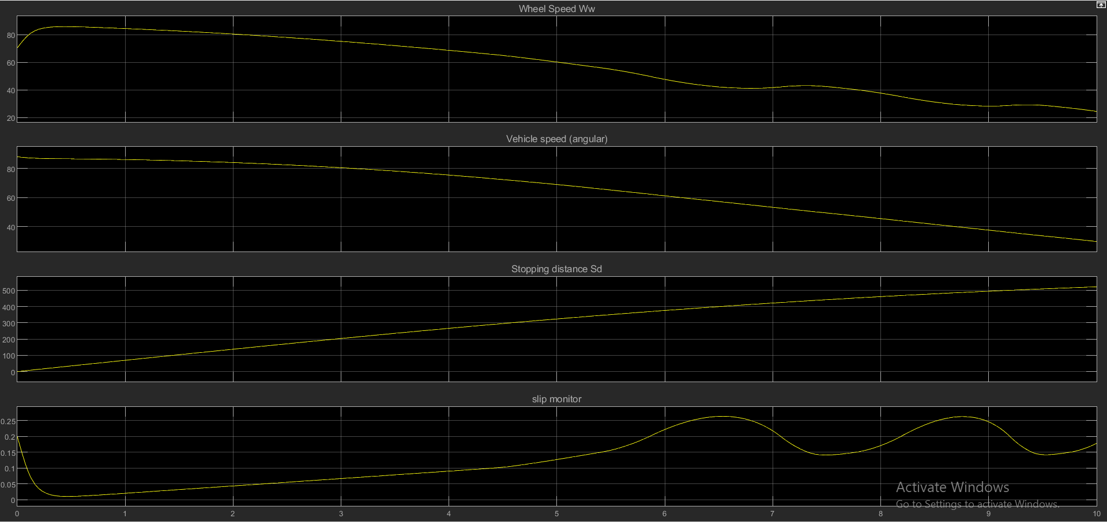

*Figure 3 model simulation output*

## Chapter 5

# Conclusion

This model shows how you can use Simulink to simulate a braking system under the action of an ABS controller. The controller in this example is idealized, but you can use any proposed control algorithm in its place to evaluate the system's performance.

## References

1. ROBERT. BOSCH, G. (2018). *BOSCH AUTOMOTIVE HANDBOOK.* SAE SOC OF AUTOMOTIVE ENG.
2. [https://www.mathworks.com/help/simulink/slref/modeling](http://www.mathworks.com/help/simulink/slref/modeling-an-anti-)-an-anti[-](http://www.mathworks.com/help/simulink/slref/modeling-an-anti-) lock-braking-system.html;jsessionid=40f91b9d3d12878d9f3359724780
3. Rohilla, Pradeep, and Akshay Dhingra. "Design and analysis of controller for antilock braking system in matlab/simulation." *International Journal of Engineering Research* 5.04 (2016).
4. <https://in.mathworks.com/help/simulink/callback-functions.html>
5. [https://www.mathworks.com/help/releases/R2020b/simulink/slref/simula tiondatainspector.html](https://www.mathworks.com/help/releases/R2020b/simulink/slref/simulationdatainspector.html)
6. [https://www.mathworks.com/help/releases/R2020b/simulink/slref/ndlook uptable.html](https://www.mathworks.com/help/releases/R2020b/simulink/slref/ndlookuptable.html)
7. <https://in.mathworks.com/help/matlab/math/choose-an-ode-solver.html>